**NEuropa**

**Food system niches in Europe**

**Entry form**

Together with our project partners, we at NAHhaft are looking for a variety of initiatives, so-called ‘niche innovations’, in the European food systems.

We aim to create an online platform that digitally maps and profiles a large number of niche initiatives, providing contact details of the niche actors as well as descriptive fact profiles about the diverse innovations. This allows for knowledge exchange, networking and cooperation potentials between different niche actors as well as further reproduction of these practices in many more places across Europe. Through increasing quantity and adoption in many countries, the niches can become mainstream, thereby positively affect framework conditions, and generate a sustainable change of our agricultural and food system!

For this, we need your support!

Thank you for filling out this entry form and sending it back to this email-address [helen.engelhardt@nahhaft.de](mailto:helen.engelhardt@nahhaft.de)

Your NAHhaft team

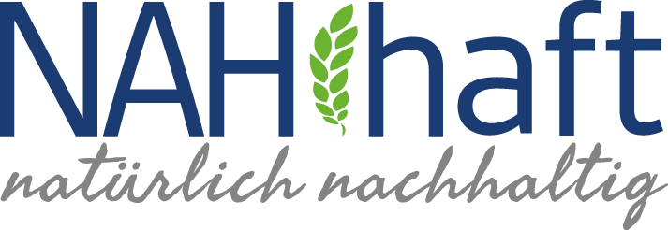

1. Contact Details
2. Last name, first name

Please type your answer here

1. Email address

Please type your answer here

1. Phone number

Please type your answer here

1. Niche innovation in short
2. Name of the initiative

Please type your answer here

1. Person/Collective responsible for the initiative

Please type your answer here

1. Contact details of initiative responsible

Please type your answer here

1. Where is the initiative practiced: Country + detailed address

Please type your answer here

1. Niche innovation description
2. Description of the initiative (max. 300 words)

Please type your answer here

1. Objectives of the initiative (max. 300 words)

Please type your answer here

1. Niche innovation’s sustainability potential

**(Please tick as many boxes as applicable)**

Ecological goals

Conservation of biodiversity

Soil protection

Water protection

Climate protection

Resource efficiency in production and consumption

Promotion of regional and closed nutrient cycles

Please add or specify if desired

Social goals

Access to healthy nutrition

Promoting awareness of sustainability nutrition

Creating transparency of previous process stages

Increasing participatory governance possibilities

Promotion of community building

Animal welfare

Fair working conditions and benefits for small-scale food producers and workers

Please add or specify if desired

Economic goals

Promotion of organic farming and sustainable production methods

Strengthening regional economic cycles

Promoting a circular economy

Promotion of diverse business structure

Food security

Fair producer prices and employment opportunities

Please add or specify if desired

1. Optional: Please detail any other relevant information about the niche innovation using the questions below as a guide (max. 1.000 words)
   * What is new/innovative about it?
   * Who are the main actor groups (e.g. producers, consumers, community groups, schools, environmental organisations, etc.)?
   * How long has the initiative been running?
   * At what point in its development is it?
   * What current obstacles need to be overcome (e.g. legal obstacles, infrastructure, lack of awareness on the consumer side, high energy consumption, etc.)?
   * What forms of cooperation would be helpful to further develop and expand the niche?

Please type your answer here

1. Optional: Have you heard of similar initiatives/examples elsewhere (other region/country)? Please name them

Please type your answer here

Thank you for your time, we are looking forward to your response!

Your NAHhaft team